UDP wireshark lab

1. Source Port, Destination Port, Length, CheckSum.

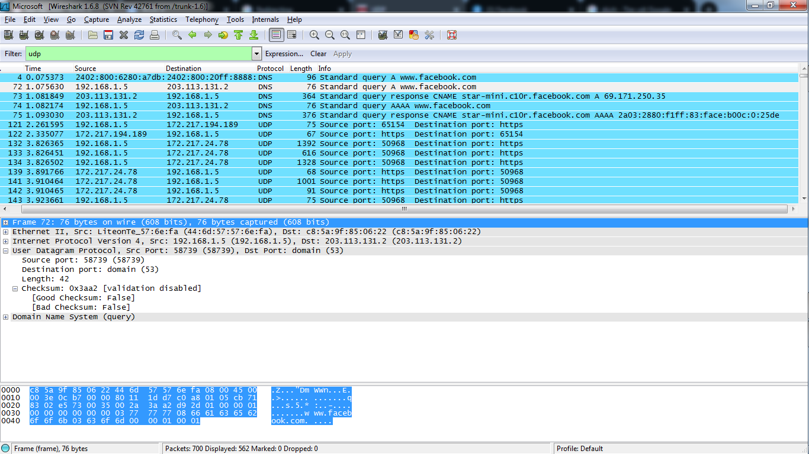

1. Each of the UDP header fields is 2 bytes long
2. The value in the length field is the sum of the 8 header bytes, plus the 42 encapsulated data bytes.
3. The maximum number of bytes that can be included in a UDP payload is 216 – 1 less the header bytes. This gives 65535 – 8 = 65527 bytes.
4. The largest possible source port number is 216 – 1 = 65535.
5. The IP protocol number for UDP is 0x11 hex, which is 17 in decimal value.

**UDP sent by my host** 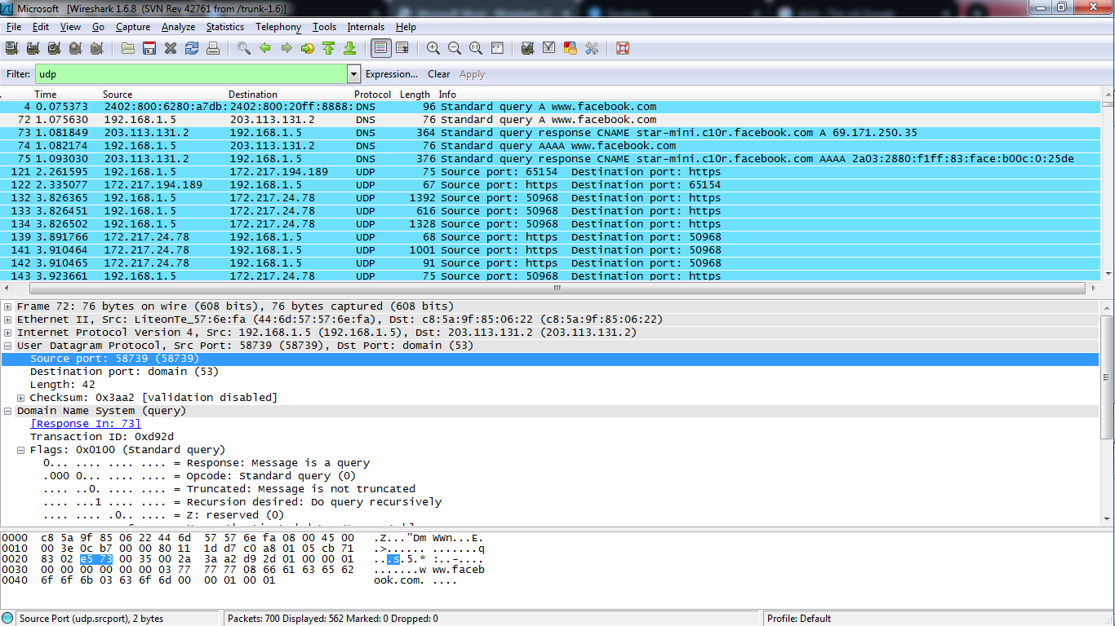

**UDP reply to my host**

